Name of the Student: G. Manasa | Academic Year: 2024 – 2028
Student Registration Number: 241U1R3007 | Year & Term: II & II
Study Level: UG | Class & Section: CSE – DS
Name of the Course: Java Programming | Name of the Instructor: Dr. A. Rajeshwar
Name of the Assessment: Lab Report - 7 | Date of Submission: 04-11-2025

Input:

Output:
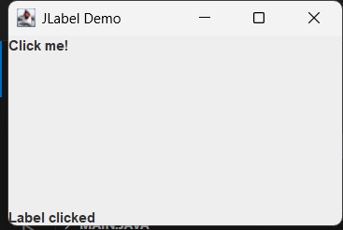

Input:

Output:
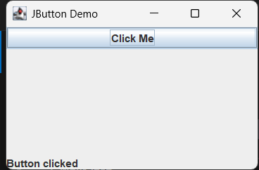

Input:

Output:
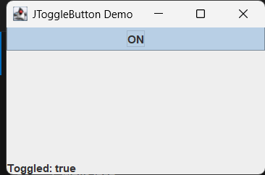

Input:

Output:
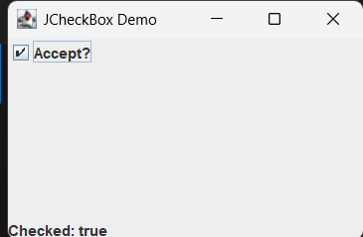
Input:

Output:
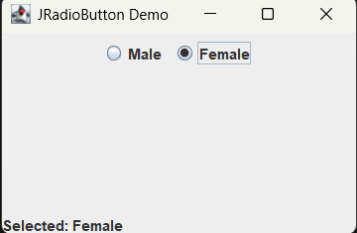
Input:

Output:
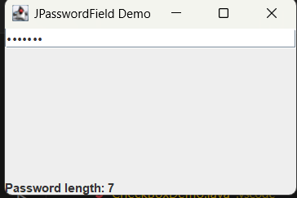

Input:

Output:
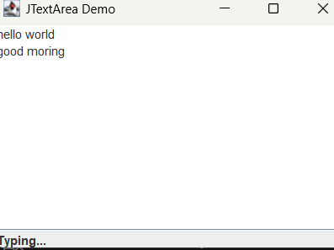

Input:

Output:
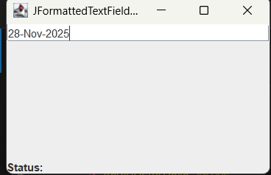

Input:

Output:
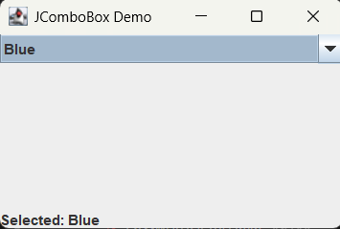
Input:

Output:
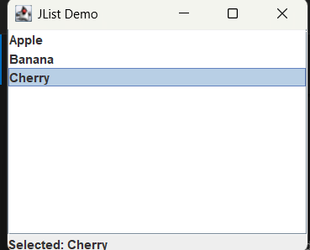
Input:

Output:
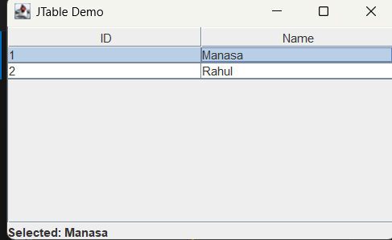
Input:

Output:
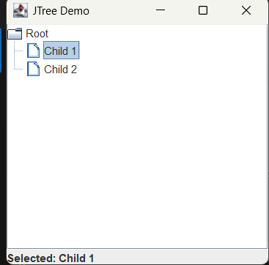
Input:

Output:
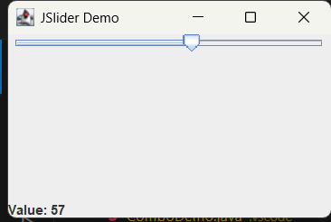
Input:

Output:
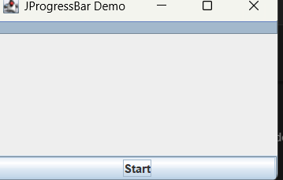
Input:

Output:
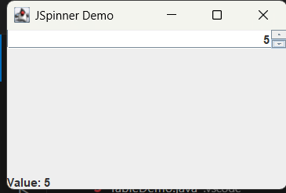
Input:

Output:

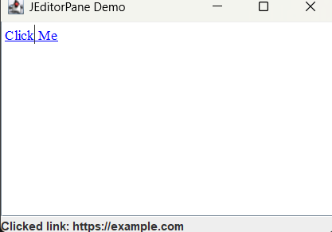

Input:

Output:

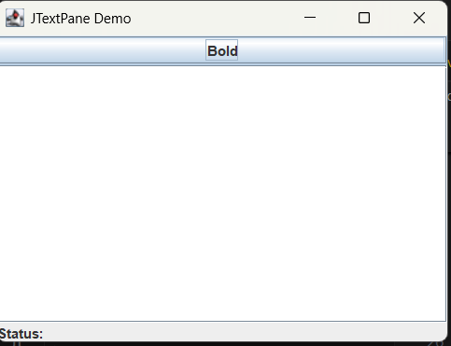

2.
